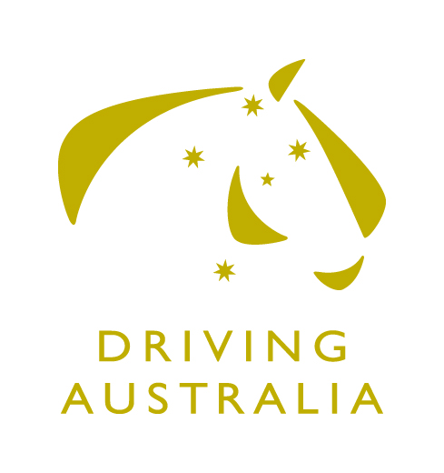

EQUESTRIAN AUSTRALIA CARRIAGE DRIVING COMMITTEE

APPLICATION FOR FUNDING GRANT
PERIOD ENDING 30 JUNE 2018

The EA Carriage Driving Committee (EACDC) is dedicated to progressing carriage driving in Australia and encouraging more participation within the sport. In a new initiative the EACDC invites organisers to apply for financial assistance to support the growth of carriage driving events, courses and education.

Who Can Apply?
Any EA affiliated club holding EA Insurance and Public Liability Insurance.

What is the Criteria for Applying?
- All events and activities must take place before the end of the current financial year (30 June 2018)
- Applications must be focused on at least one of the following:
- Development of the Sport
  - Workshops and/or seminars with the aim of encouraging more officials to become accredited
  - To conduct competitions and/or events enabling officials the opportunity for skills practice
  - To conduct events enabling drivers the opportunity to improve their driving skills including dressage, cones and marathons (i.e. combined driving events). It may be that initially a combined dressage and cones day will be held, with possibly an obstathon included
- A new FEI event seeking the provision of limited start-up funding
- Any other events that applicants may consider to be useful to encourage new drivers to come and try, with the aim of encouraging continued participation.
- Applications must be received by close of business 17 November 2017

How Do I Apply?
Applications must be lodged by close of business 17 November 2017 and sent in an electronic format to:
Equestrian Australia
Committee Liaison Manager
Kirsty Pasto, kirsty.pasto@equestrian.org.au

How will Applications be Reviewed?
The pool of funds available is not large and not all applicants may receive funding.

Applications will be reviewed by the EACDC and, at their sole discretion, grants awarded. The EACDC reserves the right to allocate funds as they see fit.

All applicants will be notified of the outcome of their application before the end of November 2017.

What are the Terms & Conditions?
- Any grant funding provided must be fully expended by 30 June 2018.
- The EA Carriage Driving Committee will have the final decision in relation to the allocation of funding.
- For successful grant applicants, payments will be made in two instalments, subject to:
- a valid tax invoice must be provided for the full amount (100%) of the funds and submitted to EA no later than 15 January 2017.
- On receipt of a valid tax invoice, 60% of the funds will be paid within 30 days.
- The remaining 40% will be paid within 30 days of receiving the post event report.
- Payments cannot be rolled over into the next financial year and no funding will be paid after 30 June 2018.
- The post event report is to be received within two (2) months of the event’s completion and should include:
  - Profit & Loss Statement
  - Number of participants
- While EA encourages events that are successful in their funding application to use Scoreboard provided by Nominate for their entry system solution, it also recognises that the level of the event being held, may not justify the use of this system.
- Any Officials Courses must be run in conjunction with the State Branch and the EA Pathway Manager – Officials.

Application Form - General Information

Name of Event Activity
Planned Date of the Event
Activity
Sport/Discipline
Venue/Location
Funding Amount Requested
How exactly will the funds be used? Please give as much detail as possible as this will increase the likelihood of your application being approved
Is the event/applicant GST-Registered? | Yes/No
Are you applying for or are you receiving any funding from any other source (including EA High Performance funding)?  Circle relevant answer | No  Yes – please provide details

Contact Details:
Name:

Contact number:

Email:

Position Held:

Event Objectives:
Please summarise the aims and objectives for this event;

Describe the actions your organisation plan to implement to achieve these objectives:

Are there any other local events that you know of taking place in the same time frame?
No

Yes – please provide details

Event Benefits;
Outline any other events which will accompany your event such as conferences or workshops. Please include details of anticipated venue and attendance.

What is the benefit to coaches and officials?

What are the general benefits to the area in which the event is held? Please outline any benefits that you envisage for the wider community.

Event – other information:
Has this event been conducted in Australia before? If yes, where and when?

Organising Committee:
Please list names and functions of OC members or attach copy of OC structure.

What previous experience has your organisation or OC had in the management of major events?

If the application is successful, then a Profit & Loss Statement will be supplied and you will be requested to complete at the end of the event. The final funds will be withheld until this form is received – all monies have to be applied for and paid before the end of the 30 June 2017.

If the applicants have more than one event planned to take place before the end of the financial year, then please copy and supply details of any other events so that when funding is being considered, this can be taken into account.
Please supply details of events held in the past two years, so that the committee can gain an idea of experience in running events.

Declaration:
I declare to the best of my knowledge that the information contained in this application is accurate and true.
If funding is provided, the Organising Committee will comply with the funding conditions. All events that receive funding will need to provide a copy of the Profit & Loss Statement for the event, their Organising Committee structure and submit a post event report within 2 months of the completion of the Event(s).

Print Name: …………………………………………

Signature: ……………………………………………

Date: …………………………………………..

