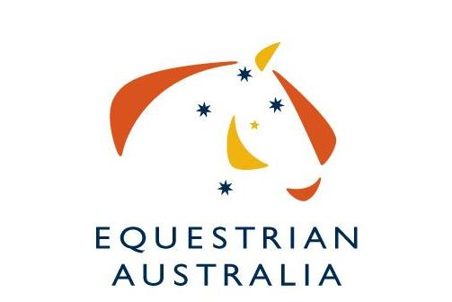

Expression of Interest for hosting the
2018 or 2019 Australian Vaulting Championships.
The Australian National Vaulting Championships are the pinnacle event for Australian Vaulting competitors.
We are interested in seeing the highest-possible standards of event organisation, so we have put together this document for organisers interested in conducting the event.
Applicants should complete the Expression of Interest form below and return to Equestrian Australia by the 26th May 2017.
Some of the areas you need to consider are:
- Organising committee members, officials , volunteers
- Venue facilities
- Program
- Media / Photographer / Video Operator
- Sponsorships
- Equipment
- Spectators

Budget: Some external funding is potentially available through the EA International Competition Development Fund (ICDF). It is possible that Federal and State Government Grants may also be applicable. http://www.equestrian.org.au/ICDF

Applications close 26th May 2017.

Please send all Expressions of Interest to the EA National Office via email to kirsty.pasto@equestrian.org.au. Please also specify which year (2018 or 2019) your EOI is for.

We thank you for your interest.

Expression of Interest to run the
2018 or 2019 Australian Vaulting Championships

Name of Organising Committee:

Date of Event: __________________________________________________________________________

Location of Event:

Name of main contact:

Mobile
Email

Event website:

- Please describe previous experience at organising major national (or state) level vaulting events in Australia. Give details of the last major event your OC organized.

2. Names of proposed organizing committee members.

Name | Role

3. Names of proposed officials.

Name | Role | Location
 | FEI International Judge
 | Scorer
 | TD
 | Vet

4. A list of available and willing volunteers (plus back up for key roles) volunteers who have training or skills to manage the various functions of successful Championships, especially an experienced scorer and assistant scorer, together with an experienced music operator and assistant.

Name | Role | Experience / Skills
 | Scorer
 | Assistant Scorer
 | Music Operator
 | Assistant Music Operator
 | Stable Manager
 | Parking Attendant

5. The program of classes you intend to conduct (refer to the standard schedule).

Day 1 | Classes
Day 2 | Classes
Day 3 | Classes

6. The number of spectators you expect for the duration of the competition.

7. Expected media coverage. (Advertisements or ‘editorials’ in newspapers, radio promotion, posters, the website and other news coverage.)

8. Please indicate who you will be organizing as the photographer and video operator to be in attendance at the Championships.

Photographer
Video Operator

9. Expected sponsorship or funding of this event.

10. Details of the indoor venue (rings/arenas/spectator seating/ media room/ music room)
11. Details of the venue facilities e.g. stabling, camping, amenities, wash bays

12. Estimate numbers of horse places that will be available to Australian & overseas competitors.

Australian | Overseas

13. Details of equipment (music, computers etc)

14. Accommodation options for competitors, officials, supporters & spectators.

Name | Location | Contact Details

15. Any personal development activities planned for judges, vaulters, coaches or lungers in association with an International Judge i.e. Clinics, protocol days etc.

16. Other relevant information supporting your committee’s wishes to stage the 2016 Australian Vaulting Championships.

EOI must be received by 26 May 2017

EOI and all enquiries to be addressed to:
Committee Liaison Manager
Kirsty Pasto
Equestrian Australia, PO Box 673, Sydney Markets, NSW 2129
FAX: 02 9763 2466
PH: 02 8762 7777
Email: kirsty.pasto@equestrian.org.au

