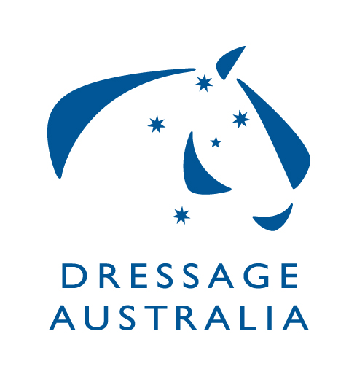DRESSAGE TECHNICAL DELEGATE REPORT
STATE & NATIONAL CHAMPIONSHIPS
REGIONAL CHAMPIONSHIPS & CLUB EVENTS

Refer to rule 6.3 in the current rule book for the role and responsibility of a TD

Date/s of Event:
Name of Event:
Location of Event:
Number of Competitions Held:
Official Competitive | YES NO
AOR | YES NO
PARA EQUESTRIAN | YES NO
YOUTH | YES NO
Participation | YES NO
Level of Competitions Offered e.g. Novice, Medium etc:

SCHEDULE | YES | NO | Comment
Did the TD have input and approve the Schedule prior to it being published
ADMINISTRATIVE | Yes | No
Was the OCs current Risk Management Plan made available to you?
OFFICIALS | YES | NO | Comment on Aspects that Need Improving and reasons why any areas not according to EA Dressage Rules
Was the Technical Delegate present for the whole event?
Were all appointed Judges officiating within their accredited level?
Was the Event Office accessible to officials and competitors?
Was a Chief Steward appointed?
Was the Chief Steward paid in accordance with recommendations as per the current rules
Were sufficient Stewards present?
Was a Gear Check steward appointed?
Were writers at the venue in sufficient time and also efficient?
Were there sufficient Runners/Sheet Collectors?
Were there a sufficient number of scorers?
Was Electronic or paperless scoring used?
Was the event conducted according to the schedule?
Was the Programming of competitions OK?
Did the draw give judges enough breaks during the competition?
OFFICIALS Continued | YES | NO | Comment on Aspects that Need Improving and reasons why any areas not according to EA Dressage Rules
Did the draw give judges enough time between competitions?
Did you have good communication with the Organising Committee leading up to the Event?
Did you have good communication with the Organising Committee during the Event?
Was accommodation provided if required?
Were meals provided for officials?
Was transport provided for Officials if required?
Did all judges receive a copy of the timed draw?
Did judges receive an updated draw with scratchings each morning?
Did judges receive a copy of the results for the competitions they judged?
Were results presented in the prescribed and timely manner to judges?
Were judges paid the recommended travel subsidy in accordance with the rules?
Were judges paid for judging as per the recommendation in the rules?
Were judges allocated competitions so that they weren’t judging the same horses/riders? E.g. Had comps at least one or more levels apart e.g. Prelim – Elementary – Advanced etc. If ‘no’ were judges at least placed in a different position on the arena?
Did horse EA Medication Control take place at this event?
GROUNDS | YES | NO | Comment on Aspects that Need Improving and reasons why any areas not according to EA Dressage Rules
Was stabling provided if required?
Was stable bedding available?
Were yards available?
Were competitor Tack Rooms available?
Were wash bays available?
Was the camping area suitable?
Was parking sufficient for competitors?
Was parking sufficient for spectators?
Were spectators cordoned off a sufficient distance from arenas?
Were there sufficient canteen/food outlets?
Were trade stands placed a safe distance from horse areas (if applicable)?
Was security provided during the event e.g. stables, trade stands?
Were there any safety risks?
Were any identified safety risks attended to?
Was safety an OC priority during event?
Were the requirements of the EA Hot Weather Policy complied with? If so how?

COMPETITORS | YES | NO | Comment on Aspects that Need Improving and reasons why any areas not according to EA Dressage Rules
Were arenas set up and safely constructed in accordance with the rules?
What constituted the arena surface? E.g. grass, sand, sand mix, fibre
Were sufficient warm-up areas provided and of a similar surface to the competition arena? Name surface/s provided
Were First Aid/Medical Services available?
Were there any falls of Horse and/or Rider?
Was a First Aid official present?
Was there any Welfare of the Horse/Abuse issues?
Did the draw give competitors sufficient time between tests Draw?
Were the timed draws sent to competitors in a timely manner?
Were updated draws available first thing each day showing scratchings?
Were any presentations mounted?
Was the prize money/goods in kind allocated in accordance with the rules?
Was there adequate Horse/Public safety?
Was the communication between all Officials & OC satisfactory?
Was security available during the event?
Were results completed in a timely manner
Were there facilities e.g. Rider Retreat available for the riders?
Was a loudspeaker system in place and could it be heard?

If additional information is to be provided, please attach on a separate page
This report is to be completed and forwarded to:
- National C’Ships – EADC, Event Director & OC
- State C’Ships - State Dressage Authority (SDA) & Event Director & OC
- All other events – OC

Within 21 (preferably 14) days of the event

