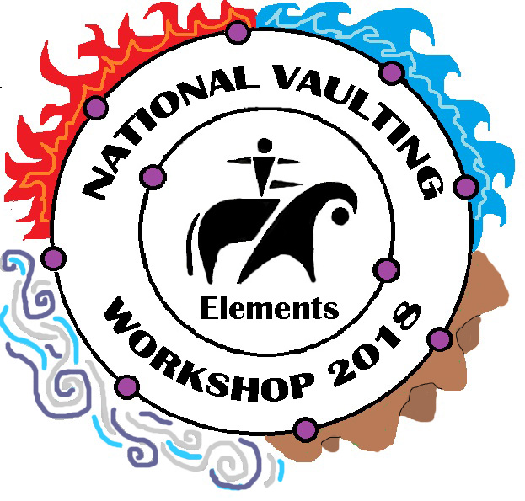
Elements
DRAFT TIMETABLE 14/1/18
Please note adjustments may still occur

TUESDAY 16th January
 | Arena | Barrel Area/Other |  | Electrons
8:00-8:45 | Arrival and final registration
9:00 | Elements – Introduction
9:45 |  | Foundation elements – demo/ground |  | Foundation elements
10:15 | Horse elements | Foundation elements – barrel |  | Compounds – working together (acro)
11:15 | Break
11:30 | Horse elements | Foundation elements – barrel |  | Foundation elements – barrel/horse
12:30  LUNCH | Lunch - Water Elements (Pool trip weather permitting) |  |  | FINISH
2:00 | 1:30 Coaching elements session – Planning the week | Group 1 – Earth and Air (acro) | Group 2 – Earth to Air (mounts)
2:00 | 2:30 Elements of lunging  – Theory and Practical | Group 2 – Earth and Air (acro) | Group 1 – Earth to Air (mounts)
4:00 | Break
4:15 | Feeling the elements - earth time
4:45 | Mentor session
5:00 | FINISH
5:15-6:15 | Extension barrel session

WEDNESDAY 17th January
 | Arena | Barrel Area/Other |  | Electrons
8:00 | Riding Element (Riders) T
9:00 | Elements of Everything (All)
9:20 | Out in the elements – Training out of the arena
9:45 | Break/Horse Prep
9:55 | Horse Elements - Group 1 | Elements of Surprise Group 3 | Reading the Elements Group 2 | Horse Element
10:40 | Break/Horse Prep
10:50 | Horse Elements – Group 2 | Elements of Surprise Group 1 | Reading the Elements Group 3 | Finding the elements – barrel
11:35 | Break/Horse Prep
11:45 | Horse Elements - Group 3 | Elements of Surprise Group 2 | Reading the Elements Group 1 | Theory of Elements – compulsory ground work and drawing
12:30  LUNCH | Lunch |  |  | FINISH
2:00 | 1:30 Coach’s Element - Season and session planning  2:30 Lunger’s Element – Individual training sessions | Group Rotations  Force of elements /Elemental freestyle/  More Air aerial (to leave 1:30)
4:00 | Break
4:15 |  | Weathering the elements – mental and physical challenges.  Finding Air – de-stimulation techniques
5:00 | Mentor session
5:15 | FINISH
6:00 | River Picnic – weather pending

THURSDAY 18th January
 | Arena | Barrel Area/Other | Electrons
8:00 | Riding Element (Riders) S /Open vaulters horse session
9:00 | Elements of Connection (All)
9:20 | Connecting the elements – Training together
9:45 | Break/Horse Prep
9:15 |  | Demonstration –  Connecting the elements | (with full program)
9:45 | Break/Horse Prep
9:55 | Lunger’s Element - Individual training sessions | Creating compounds G1  /Performance Groups G2 | (Extension barrel sessions)
10:40 | Break/Horse Prep
10:50 | Compounds on the horse G1 | Creating compounds G2
11:35 | Break/Horse Prep
11:45 | Compounds on the horse G2 | Performance Groups G1
12:30  LUNCH | Lunch |  | FINISH
2:00 | 1:30 Coach’s Element – Communication (conference room)  3:00 – Scary Elements (Horse desensitisation – theory and practice) | Group Rotations  Force of elements/ Elemental freestyle  More Air aerial (this session will now leave at 4:45)
4:00 | Break
4:15 | Elements of horse care – theory/practical | Slowing the stormy elements – stretching and breathing session
5:15 | Mentor session (‘More Air’ session to leave at 4:45 – return 8:00)
5:30 | FINISH

FRIDAY 19th January
 | Arena | Barrel Area/Other |  | Electrons
8:00 | Riding Element (Riders) T
9:00 | Finding the Fire (All)
9:20 | Connecting the elements – Training together
9:45 | Break/Horse Prep
9:55 | Horse Elements - Group 1 | Air and Fire Group 3 | Playing with Fire Group 2 | Moving fire – dynamic exercises (comp and free)
10:40 | Break/Horse Prep
10:50 | Horse Elements – Group 2 | Air and Fire Group 1 | Playing with Fire Group 3 | Fire on the barrel
11:35 | Break/Horse Prep
11:45 | Horse Elements - Group 3 | Air and Fire Group 2 | Playing with Fire Group 1 | Fire on the horse
12:30  LUNCH | Lunch |  |  | FINISH
2:00 | 1:30 Lunger’s Element - Seeing the Elements | Group Rotations  Force of elements /Elemental freestyle/  More Air aerial (to leave 1:30)
4:00 | Break
4:15 |  | Picking the Elements – Tech test and ‘Compulsory’ tech test (All)
5:15 | Mentor session
5:30 | FINISH/Theory Exams

SATURDAY 20th January
 | Arena | Barrel Area/Other | Electrons
8:00 | Riding Element (Riders) S/ Extension horse session
9:00 | Elements of Variation (All)
9:15 | Finding your element Group 1 | Knowing the Elements Group 3/  Elements of Lunging G 2(for vaulters) | Earth training – Acro
10:00 | Break
10:15 | Finding your element Group 2 | Knowing the Elements Group 1/  Elements of Lunging G 3 (for vaulters) | Foundation setting – practice performance (comp or free)
11:00 | Break
11:15 | Finding your element Group 3 | Knowing the Elements Group 2/  Elements of Lunging G 1 (for vaulters) | Playing in orbit – games on the horse
12:30  LUNCH | Lunch – Water Elements (Pool trip weather permitting) |  | FINISH
1:30 | Competition Element – Perform and Judge
3:30 | Break
3:45 | 3:00 Coaching/Lunging Assessments | Performance Preparation
4:30 | Internal Elements – visualisation/relaxation
4:45 | Mentor session
5:00 | FINISH
6:00 | SHOWING THE ELEMENTS - Performance and Games
7:30 | BBQ

