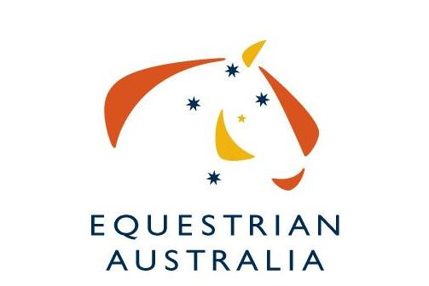
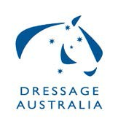

2020/21 National Dressage Performance

Gold Medals

The Equestrian Australia Dressage Committee is once again supporting a special Gold Medal System to recognise outstanding performances throughout the year. Gold medals have been distributed every year since 2010.

2020 & 2021 National Dressage Performance Gold Medals have been combined due to the impact of Covid-19 on events during 2020 and will be awarded to horse/rider combinations who obtain the following in the qualifying period as stated below.

Gold Medals (Does not include Freestyles):
- Novice or Elementary level - 3 performances of 75% or more at each level
- Medium or Advanced level - 3 performances of 70% or more at each level
- PSG or Inter I (small tour) - 3 performances of 70% or more across the small tour
- Inter II or Grand Prix (big tour) - 3 performances of 70% or more across the big tour

Conditions:
- The qualifying period is from 4th September 2019 to 1st September 2021 (the period from the closing date of entries for the 2019 Australian Dressage Championships up to the closing date for entries for the 2021 Australian Dressage Championships).
- Australian riders are eligible.
- Riders must be current financial members of Equestrian Australian to be eligible.
- Performances can be from any Official competition.
- Official Competitive overall scores only will be eligible (not individual judges scores).
- HC results are not eligible.
- Freestyle results are not eligible.
- Performance medals will be presented at the 2021 Australian Dressage Championships on a day and time to be determined.

Please complete the following nomination form and return to karen.myers@equestrian.org.au at Equestrian Australia no later than Close of Business Thursday 30th September 2021.

2020/21 National Dressage Performance Gold Medals

Nomination Form

Details of performances must be submitted to Equestrian Australia by Thursday 30th September 2021.

Please complete a separate form for each horse you wish to nominate.

Name of Horse |  | Horse EA Number
Name of Rider |  | Rider EA Number
Name of Owner |  | Owner EA Number

Date | Venue/Club | Competition e.g. 3D | O/All %

Email form to: karen.myers@equestrian.org.au before Thursday 30th September 2021.

