FEI CALENDAR APPLICATION FORM 2023
Event Details
Name of Event:
Venue Location including State:
FEI Competition Start Date:
FEI Competition End Date:
Name of Organising Committee:
Discipline/s:
FEI Event Category: (inclusive of star rating & all classes required eg CCI3*-S or -L, )
FEI Competition will be run Indoor/Outdoor for the main class:

Contact Details – for all correspondence
Contact Name:
Contact Address:
Contact Phone Number:
Contact Email Address:
Schedule Admin Contact Name:
Schedule Admin Contact Phone Number:
Schedule Admin Contact Email Address:
Name and email for forwarding of FEI fees if different to above:

Please send your FEI Calendar Applications by the closing date of the 5pm Monday 1st August 2022 to:
Equestrian Australia
Sport Services Officer
caiwen.cusworth@equestrian.org.au

EVENT PAGE TEMPLATE
To have your event listed on Equestrian Australia’s website Calendar, please complete and return the below form to caiwen.cusworth@equestrian.org.au
Discipline
Name of Event
Start date |  | End date:
Organiser
Email contact
Location (precise venue’s address)
Event’s website
Facebook Page link
Twitter Page link
Instagram Page link
Live streaming link
Live score link
Please supply a HORIZONTAL photo or event’s banner to illustrate your event. Example :
(For example, it can be your Facebook page’s top header banner called COVER PHOTO)
Size of the banner needs to be 1130 x 430 pixels, see below.

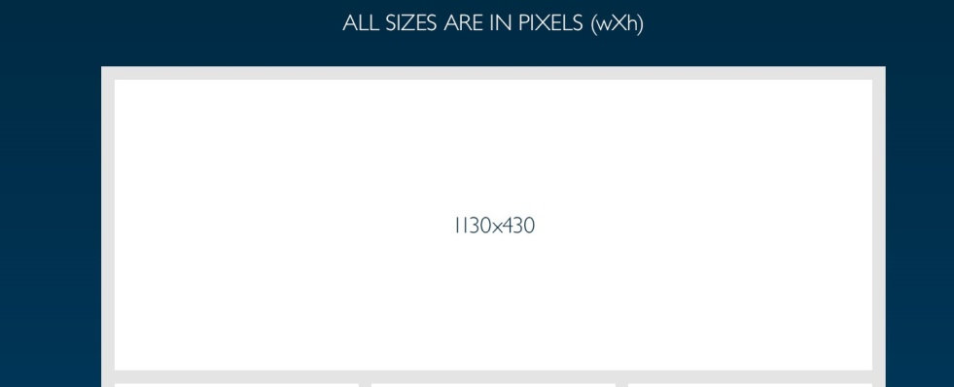

About Your Event:
(Write a short text introducing your event. Level and what the general public can find)

