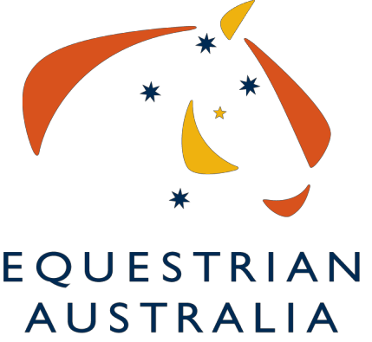
Equestrian Australia Limited
ABN 19 077 455 755

www.equestrian.org.au

PO Box 673, SYDNEY MARKETS, NSW, 2129 – Fax 02 9763 2466

Nomination for Athlete Appointed Director

I,
of
nominate
for appointment to the Board of Equestrian Australia Limited.

Signed
Date

Consent of Nominee:

I,
of

agree to be nominated for appointment to the Board of Equestrian Australia Limited (EA).
I have read the EA Constitution and understand the commitment in time and intellectual contribution I will be expected to make. I also confirm that I meet the other requirements to be a Director of EA, especially in terms of skills and the need to work for the good of the whole organisation and the sport. Nominees for appointed director position on the Board must be a current participating member.

Signed
Date

Please send the form to Lucy Warhurst by 5pm on Monday 28 January 2019
Nominees must attach to their nomination form a résumé not exceeding 400 words to support their nomination, using the résumé template. They may also attach a passport sized photograph or forward a digital image together with a digital file of the completed résumé template to lucy.warhurst@equestrian.org.au

