EQUESTRIAN AUSTRALIA NDC AGENDA TEMPLATE


Sport Rule Review & Updates

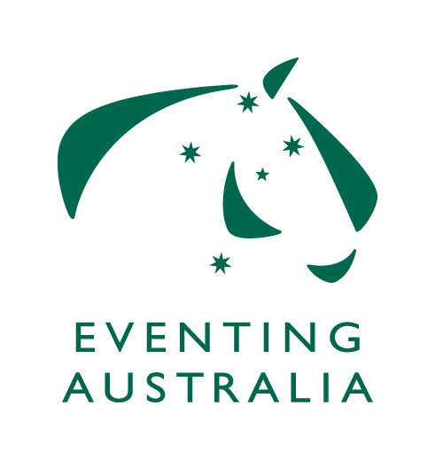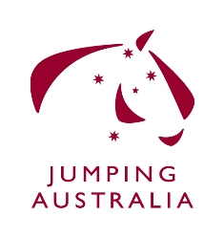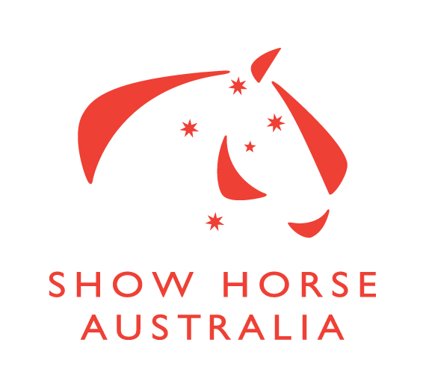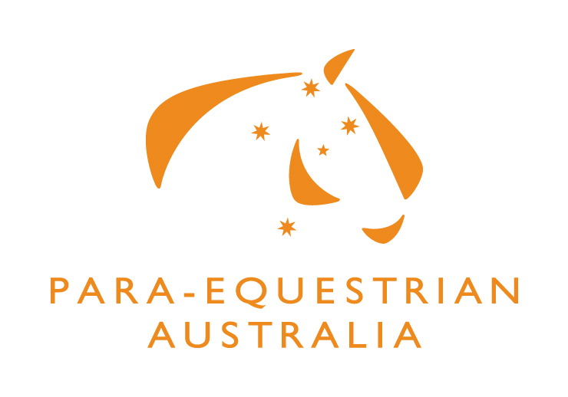
Agenda Item No: (leave blank)

Discipline/Subject:
Issue:
* including brief history. Please include the rule in full and page number of rulebook

Recommendations:
- Please suggest amended wording for Rule Change

Prepared By:

EA OFFICE USE ONLY
Staff Initials: Date Received: Date of Meeting:

