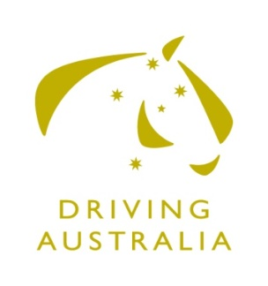
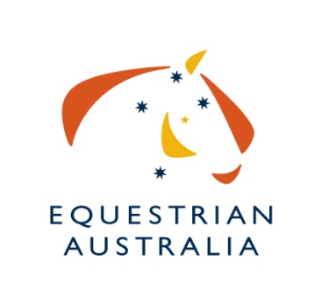
Nomination for Equestrian Australia Committee Athletes’ Representative

Committee Information:
Committee Name: Equestrian Australia Driving Committee
Application Closing Date: MONDAY 31st May 2021

Personal Details:
Name: |  |  | EA Member No:
Street Address:
Suburb: |  | State: |  | Postcode:
Email:
Mobile: | Telephone:

Business Skills and Experience:
(Include Training and Education)

“Sport Governance” Skills and Experience:
(memberships, Committee Experience)

Sport Knowledge and Involvement
(Achievements & Participation as a: Rider, Official. Event Organiser etc)

Other Relevant Information

Time Willing To Dedicate to Committee Duties
(Review of Documentation, Assistance to National Office, Projects etc)
Number of Hours:

Declaration:
I, ____________________________________have read the EA Committee Bylaws, EA Driving Charter, EA National Discipline Committee Appointment and Procedures Policy and the Athletes’ Representative Position Description for the National Committee and understand the commitment in time and contribution I am expected to make. I confirm that I meet the requirements to be a Committee Member of EA, in terms of skills and the need to work for the good of Equestrian Australia and the sport itself.

Signed: _________________________________________________Date:___________________

Return:
Form must be signed and dated and returned via email to: karen.myers@equestrian.org.au – EA Sports Services Officer (Driving)

