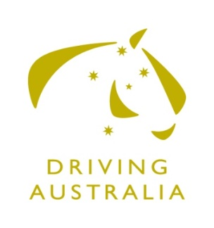
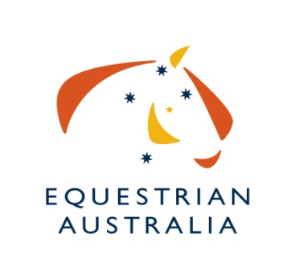
Nomination for Equestrian Australia

Driving Committee

Committee Information:
Committee Name: EA DRIVING COMMITTEE
Application Closing Date: FRIDAY 29th November 2019

Personal Details:
Name: |  |  | EA Member No:
Street Address:
Suburb: |  | State: |  | Postcode:
Email:
Mobile: | Telephone:

Business Skills and Experience:
(Include Training and Education)

“Sport Governance” Skills and Experience:
(memberships, Committee Experience)

Sport Knowledge and Involvement
(Achievements & Participation as a: Rider, Official. Event Organiser etc)

Other Relevant Information

Time Willing To Dedicate to Committee Duties
(Review of Documentation, Assistance to National Office, Projects etc)
Number of Hours:

Declaration:
I, ____________________________________have read the EA Committee Bylaws, EA Driving Charter and the EA National Discipline Committee Appointment and Procedures Policy and understand the commitment in time and contribution I am expected to make. I confirm that I meet the requirements to be a Committee Member of EA, in terms of skills and the need to work for the good of Equestrian Australia and the sport itself.

Signed: _________________________________________________Date:___________________

Return:
Form must be signed and dated and returned via email to: karen.myers@equestrian.org.au – EA Committee Liaison Manager.

