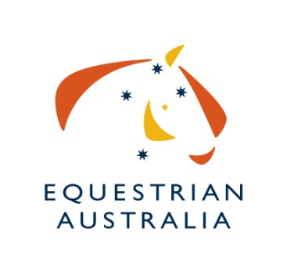
Nomination for Equestrian Australia

Exemption Committee - Dressage

Committee Information:
Committee Name: EA EXEMPTION COMMITTEE – DRESSAGE
Application Closing Date: WEDNESDAY 7th SEPTEMBER 2022

Personal Details:
Name: |  |  | EA Member No:
Street Address:
Suburb: |  | State: |  | Postcode:
Email:
Mobile: | Telephone:

PLEASE TICK APPLICABLE ROLE:

⬜ - Accredited Para Equestrian Classifier

⬜ - Dressage judge with knowledge of judging athletes with a disability

⬜ - Appropriately qualified coach with experience coaching athletes with a disability

QUALIFICATIONS and Experience:
(Include Training and Education)

“Sport Governance” Skills and Experience:
(memberships, Committee Experience)

Sport Knowledge and Involvement
(Achievements & Participation as a: Rider, Official. Event Organiser etc)

Other Relevant Information

Declaration:
I, ____________________________________have read the EA Exemption Committee - Dressage Terms of Reference and understand the commitment and contribution I am expected to make. I confirm that I meet the requirements to be a Committee Member of EA, in terms of skills and the need to work for the good of Equestrian Australia and the sport itself.

Signed: _________________________________________________Date:___________________

Return:
Form must be signed and dated and returned via email to: karen.myers@equestrian.org.au – EA Sport Services Officer (Dressage)

