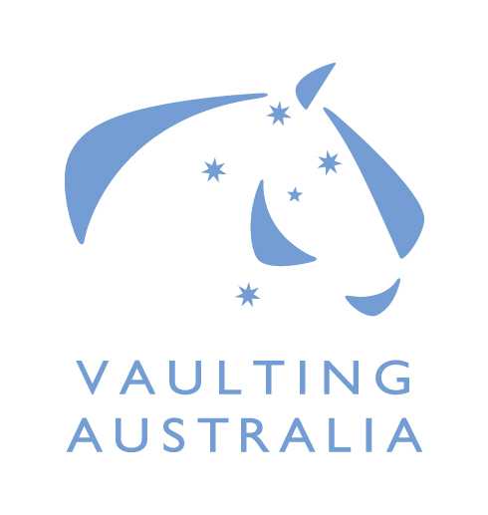

Nomination for Equestrian Australia Vaulting Committee

Committee Information:
Committee Name:
Application Closing Date:

Personal Details:
Name: |  |  | EA Member No:
Street Address:
Suburb: |  | State: |  | Postcode:
Email:
Mobile: | Telephone:

Business Skills and Experience:
(Include Training and Education)

“Sport Governance” Skills and Experience:
(memberships, Committee Experience)

Sport Knowledge and Involvement
(Achievements & Participation as a: Rider, Official. Event Organiser etc)

Time Willing To Dedicate to Committee Duties
(Review of Documentation, Assistance to National Office, Projects etc)
Number Of Hours:

Declaration:
I, ____________________________________have read the EA Committee Bylaws, EA Vaulting Committee Charter and the EA NDC Appointment and Procedures Policy and understand the commitment in time and contribution I am expected to make. I confirm that I meet the requirements to be a Committee Member of EA, in terms of skills and the need to work for the good of Equestrian Australia and the sport itself.

Signed: _________________________________________________Date:___________________

