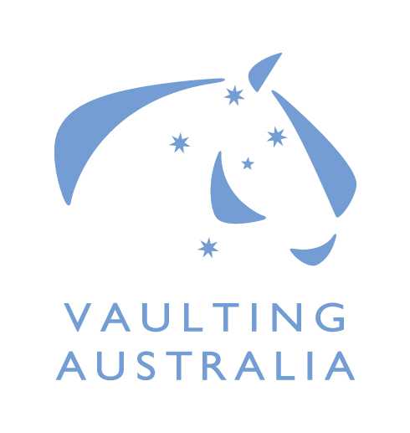
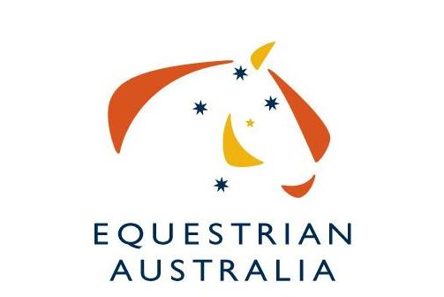
Expression of Interest
2024 FEI World Vaulting Championships, Seniors

15-21 July 2024, Bern (SUI)
Vaulters’ Name:
EA Membership No:
FEI Membership No:

Address (AUS):
Address (OS)
Mobile: |  |  | Individual Female  Individual Male | Pas de deux  Squad
E-mail:

Category and Horse Nomination:

Athletes |  |  | Lungers
Family Name | First Name | FEI ID Number | Family Name | First Name | FEI ID Number

Horses |  | Horse Qualifying results
Name | FEI ID Number | Event / Date / Score

Competitive History/Results

Any other relevant information:

Please attach any other information that may assist your application
I hereby make my application to be considered to represent Australia at the 2024 FEI World Vaulting Championships for Seniors, and if selected, agree to abide by the rules and regulations of EA and the Event.

SIGNED: .................................................................................. DATE: ....../....../......

Due Date: Monday 27th May 2024 .
This form is to be completed and returned via email to:

Di Saunders, High Performance Sports Manager
Email: di.saunders@equestrian.org.au
Phone: +61 407 728 763

