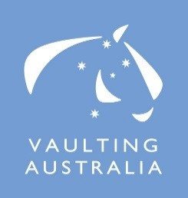
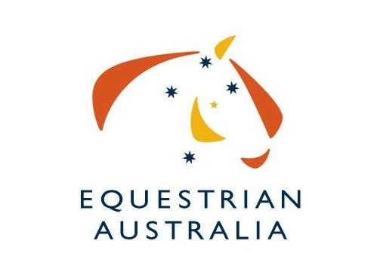
Expression of Interest for hosting the 2017 Australian National Vaulting Championships.
The Australian National Vaulting Championships are the pinnacle event for Australian Vaulting competitors.

We are interested in seeing the highest-possible standards of event organisation, so we have put together this document for organisers interested in conducting the event.
Applicants should complete the Expression of Interest form below and return to Equestrian Australia by Tuesday 1st March 2016.
Some of the areas you need to consider are:
- Australian Vaulting Rules
- EA National General Regulations
- Preferred date of Nationals – September/October 2017
- Organising committee members, officials , volunteers
- Venue facilities
- Program
- Media / Photographer / Video Operator
- Sponsorships
- Equipment
- Spectators

Budget: Some external funding is potentially available through the EA International Competition Development Fund (ICDF). It is possible that Federal and State Government Grants may also be applicable.

Applications close Tuesday 1st March 2016.

Please send all Expressions of Interest to the EA National Office either via email to stefanie.maraun@equestrian.org.au or by fax 02 9763 2466.

We thank you for your interest.

Expression of Interest to run the 2017 Australian Vaulting Championships
Name of Organising Committee:

Date of Event:

Location of Event:

Name of main contact:

Mobile
Email

Event website:

1. Please describe previous experience at organising major national (or state) level vaulting events in Australia. Give details of the last major event your OC organized.

Name | Role

- Names of proposed officials.

Name | Role | Location
 | FEI International Judge
 | Scorer
 | TD
 | Vet

- A list of available and willing volunteers (plus back up for key roles) volunteers who have training or skills to manage the various functions of successful Championships, especially an experienced scorer and assistant scorer, together with an experienced music operator and assistant.

Name | Role | Experience / Skills
 | Scorer
 | Assistant Scorer
 | Music Operator
 | Assistant Music Operator
 | Stable Manager
 | Parking Attendant

Day 1 | Classes
Day 2 | Classes
Day 3 | Classes

- The number of spectators you expect for the duration of the competition.

- Expected media coverage. (Advertisements or ‘editorials’ in newspapers, radio promotion, posters, the website and other news coverage.)

- Please indicate who you will be organizing as the photographer and video operator to be in attendance at the Championships.

Photographer
Video Operator

10. Details of the indoor venue (rings/arenas/spectator seating/ media room/ music room)

12. Estimate numbers of horse places that will be available to Australian & overseas competitors.

Australian | Overseas

- Accommodation options for competitors, officials, supporters & spectators.

Name | Location | Contact Details

- Any personal development activities planned for judges, vaulters, coaches or lungers in association with an International Judge i.e. Clinics, protocol days etc.

- Other relevant information supporting your committee’s wishes to stage the 2016 Australian Vaulting Championships.

EOI must be received by 1st March 2016

EOI and all enquiries to be addressed to: Stefanie Maraun Equestrian Australia, PO Box 673, Sydney Markets, NSW 2129 FAX: 02 9763 2466
PH: 02 8762 7777
Email: stefanie.maraun@equestrian.org.au

