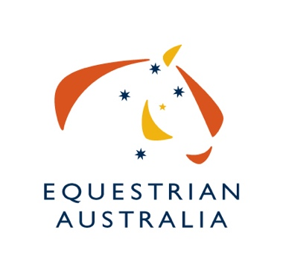

EXPRESSION OF INTEREST

TO HOST AUSTRALIA’S MAJOR DRESSAGE CHAMPIONSHIPS

Including
2022 Australian Dressage Championships
2022 Australian Pony Dressage Championships
2022 Australian Para Equestrian Championships
2022 Australian Amateur Owner Rider Championships
2021/22 Pacific League World Cup Dressage Final
2022/23 Pacific League World Cup Dressage Final

*2022 Australian Young Horse Championships & 2022 Australian Youth Dressage Championships have already been awarded.

Australia’s Major Dressage Championship Events are events conducted for and on behalf of Equestrian Australia (EA). Organising Committees (OC) are invited to submit their expression of interest to conduct one or more of these events in 2022 with the option of applying for a further 2 years 2023 & 2024. The OC and EA both have the opportunity to withdraw from the succeeding years within 6 weeks of the first year’s event. Such a withdrawal must be made in writing to the other party.

The National Discipline Committee (NDC) will assess all submissions and further details may be requested from interested parties. The NDC will then appoint the OC to run each respective Championship.

The Australian Dressage Championships should be an event in its own right, not absorbed into an existing event and should be conducted over a minimum of four consecutive days. The intent for the Australian Championships is to present an event that is equivalent to an FEI3* competition by way of standards and facilities.

Ideally the Australian Pony Dressage Championships and/or the Australian Para Equestrian Championships will be held in conjunction with the Australian Dressage Championships.
Current EA Rules for each event apply and must be adhered to when considering hosting any Australian Championship event.

Other conditions that must be adhered to include:

The NDC will appoint a Technical Delegate (TD) to assist the OC in its preparation for and conduct of the Australian Championships. The TD will operate as per Article 152 and 153 in the EA General Regulations.

The TD must submit a report to the NDC within two (2) weeks of the competition finishing.

EA assigns the rights to the marketing of the event to the OC. However, EA’s logo and/ or specific EA discipline logo is to be used as the brand logo of the Australian Championships and as part of all marketing collateral and should adhere to EA’s brand guidelines

It is the OCs responsibility to ensure there is a dedicated press centre available at the event, as well as adequate accreditation to provide media access to the event. The OC should liaise with EA to ensure all press needs are catered for in the lead up to and at the event.

The OC will invite the EA Chair, National Discipline Chair and EA CEO to appropriate functions. Event passes should be provided to other EA Board Members, EADC members, Selectors and the High Performance Director.

The OC will provide a full post event report including a financial report outlining the profit and loss, attendance numbers and sponsorship obligations within two (2) months of the completion of the event.

The OC will need to submit a risk management plan to EA three (3) months prior to the event.

The OC will be responsible for funding the event.

If you would like to apply for any event, please fill out the attached EOI form and return to the EA Office via email. Submission of the EOI form to EA signals agreement to the above conditions.

EOI’s close MONDAY 26th JULY 2021, 5pm. Please forward completed form to Karen Myers, karen.myers@equestrian.org.au

Name of event/s applying to host and proposed dates
Name of Organiser/Club
Name of Primary Contact
Phone
Email
Venue
Previous events OC have run
Any other comments/relevant information

