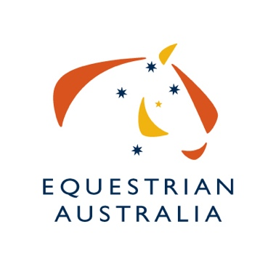

EXPRESSION OF INTEREST

To host Australia’s National Vaulting Championship for 2020

Please note this is for Nationals for 2020 only as the QLD Committee have just declined due to limited resources.

Australia’s National Vaulting Championship is conducted for and on behalf of Equestrian Australia (EA). Organising Committees (OC) are invited to submit their expression of interest to conduct this event in 2020.
Due to the limited time to organize the event, the OC can decide if they are able to run a CVI or if they are only applying to run the National Championship.

The EAVC will assess all submissions and further details may be requested from interested parties.

Current EA Rules apply and must be adhered to when considering hosting any Australian Championship event.

The OC will be responsible for funding the event.

If you would like to apply to host the 2020 National Vaulting Championships, please fill out the attached EOI form and return to the EA Office. Submission of the EOI form to EA signals agreement to the above conditions.

EOI close Wednesday November 8, 2019, 5pm. Please forward completed form to Jenny Merity at jenny.merity@equestrian.org.au

Nationals only or Nationals and CVI
(include level for CVI)
Proposed dates
Name of Organiser/s
(State Committee, Club/s name)
Name of Primary Contact
Phone
Email
Venue
Has availability been confirmed?
Previous events OC have run
Any other comments/relevant information

