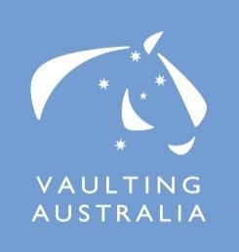
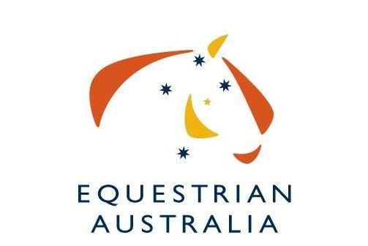

Expression of Interest for hosting the 2020 Australian Vaulting Championships.

The Australian National Vaulting Championships are the pinnacle event for Australian Vaulting competitors.

We are interested in seeing the highest-possible standards of event organisation, so we have put together this document for organisers interested in conducting the event.

Applicants should complete the Expression of Interest form below and return to Equestrian Australia by the 26th May 2017.

Some of the areas you need to consider are:

- Organising committee members, officials , volunteers
- Venue facilities
- Program

- Media / Photographer / Video Operator
- Sponsorships
- Equipment

- Spectators

Budget: Some external funding is potentially available through the EA International Competition Development Fund (ICDF). It is possible that Federal and State Government Grants may also be applicable. http://www.equestrian.org.au/ICDF

Applications close 26th May 2017.

Please send all Expressions of Interest to the EA National Office via email to Kirsty.Pasto@equestrian.org.au

We thank you for your interest.

Expression of Interest to run the 2020 Australian Vaulting Championships

Name of Organising Committee:

Date of Event:
__________________________________________________________________________

Location of Event:

Name of main contact:

Mobile

Email

- Please describe previous experience at organising major national (or state) level vaulting events in Australia. Give details of the last major event your OC organized.

2. Expected sponsorship or funding of this event.

3. Details of the indoor venue (rings/arenas/spectator seating/ media room/ music room)

4. Details of the venue facilities e.g. stabling, camping, amenities, wash bays

5. Estimate numbers of horse places that will be available to Australian & overseas competitors.

Australian | Overseas

6. Other relevant information supporting your committee’s wishes to stage the 2020 Australian Vaulting Championships.

EOI must be received by 26 May 2017

EOI and all enquiries to be addressed to: Kirsty Pasto
Equestrian Australia, PO Box 673, Sydney Markets, NSW 2129

FAX: 02 9763 2466
PH: 02 8762 7777

Email: Kirsty.Pasto@equestrian.org.au

