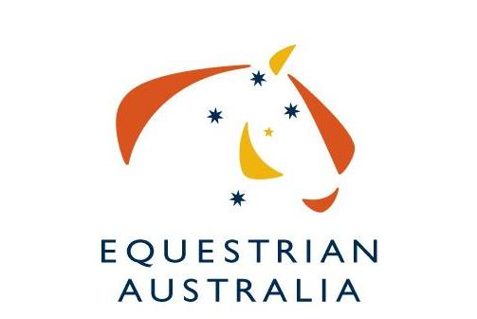
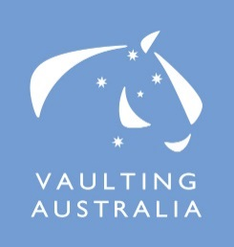
EXPRESSION OF INTEREST

Australia’s National Vaulting Championship for 2023/2024 Host
The Australian National Vaulting Championships are the pinnacle event for Australian Vaulting competitors.

Australia’s National Vaulting Championship is conducted for and on behalf of Equestrian Australia (EA). Organising Committees (OC) are invited to submit their expression of interest to conduct this event in 2023 and 2024. We are interested in seeing the highest-possible standards of event organisation, so we have put together this document for organisers interested in conducting the event.

Due to the limited time to organize the event, the OC can decide if they are able to run a CVI or if they are only applying to run the National Championship.

The EAVC will assess all submissions and further details may be requested from interested parties.

Current EA Rules apply and must be adhered to when considering hosting any Australian Championship event.

The OC will be responsible for funding the event.
Some of the areas you need to consider are:
- Organising committee members, officials, volunteers
- Venue facilities
- Program
- Media / Photographer / Video Operator
- Sponsorships
- Equipment
- Spectators

If you would like to apply to host the 2020 National Vaulting Championships, please fill out the attached EOI form and return to the EA Office. Submission of the EOI form to EA signals agreement to the above conditions.

EOI close by COB Wednesday 30th of August 2022. Please forward completed form to Victoria Farr at victoria.farr@equestrian.org.au

We thank you for your interest.

Host Expression of Interest for the
2023/2024 Australian Vaulting Championships

Name of Organising Committee:

Date of Event: __________________________________________________________________________

Location of Event:

Name of main contact:

Mobile
Email

Event website:

- Please describe previous experience at organising major national (or state) level vaulting events in Australia. Give details of the last major event your OC organized.

2. Names of proposed organizing committee members.

Name | Role

3. Names of proposed officials.

Name | Role | Location
 | FEI International Judge
 | Scorer
 | TD
 | Vet

4. A list of available and willing volunteers (plus back up for key roles) volunteers who have training or skills to manage the various functions of successful Championships, especially an experienced scorer and assistant scorer, together with an experienced music operator and assistant.

Name | Role | Experience / Skills
 | Scorer
 | Assistant Scorer
 | Music Operator
 | Assistant Music Operator
 | Stable Manager
 | Parking Attendant

5. The program of classes you intend to conduct (refer to the standard schedule).

Day 1 | Classes
Day 2 | Classes
Day 3 | Classes

6. The number of spectators you expect for the duration of the competition.

7. Expected media coverage. (Advertisements or ‘editorials’ in newspapers, radio promotion, posters, the website and other news coverage.)

8. Please indicate who you will be organizing as the photographer and video operator to be in attendance at the Championships.

Photographer
Video Operator

9. Expected sponsorship or funding of this event.

10. Details of the indoor venue (rings/arenas/spectator seating/ media room/ music room)
11. Details of the venue facilities e.g. stabling, camping, amenities, wash bays

12. Estimate numbers of horse places that will be available to Australian & overseas competitors.

Australian | Overseas

13. Details of equipment (music, computers etc)

14. Accommodation options for competitors, officials, supporters & spectators.

Name | Location | Contact Details

15. Any personal development activities planned for judges, vaulters, coaches or lungers in association with an International Judge i.e. Clinics, protocol days etc.

16. Other relevant information supporting your committee’s wishes to stage the 2016 Australian Vaulting Championships.

EOI must be received by COB Wednesday 30th of August 2022.

EOI and all enquiries to be addressed to:
Sports Services Officer
Victoria Farr
Equestrian Australia, PO Box 673, Sydney Markets, NSW 2129
FAX: 02 9763 2466
PH: 02 8762 7717
Email: victoria.farr@equestrian.org.au

