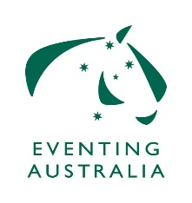 | EXEMPTION APPLICATION:  EA 520.4 EXEMPTION FROM MINIMUM ELIGIBILITY REQUIREMENTS
Rider’s Name: |  | Coach’s  Name:
EA Membership No. |  |  |  |  | Date of Birth:
FEI Membership No.
Address:
 |  |  |  | Postcode:
Mobile No:
E-mail address:
Horse Name:
Horses EA No: |  |  | Horses FEI No:
Reason for exemption requested incl. level of competition:
Please ensure that you attach detailed summary of both the horse and the rider’s performance record, including all the horse’s competitions at national and international events during the current and previous years.

EA 520.4 EXEMPTION FROM MINIMUM ELIGIBILITY REQUIREMENTS for CCNs-L & CCNs-S
A horse and rider may be exempted from the performance qualifications only, on the authority of the Equestrian Australia Eventing Committee. There shall be no exemption from FEI requirements such as riders’ age and horse age. Such a request must be accompanied by the reasons for the request and a detailed summary of both the horse and the rider’s performance record, including all the horse’s competitions at national and international events during the current and previous years. The request must be lodged with the relevant State Eventing Committee / State Branch at least ten (10) days before the close of entries. The State Branch will forward the request for exemption to the National Office for ratification by the National Eventing Committee.

This form is to be completed and returned to your State Eventing Committee / State Branch.

