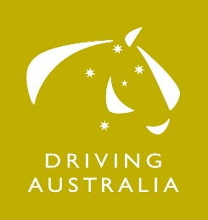
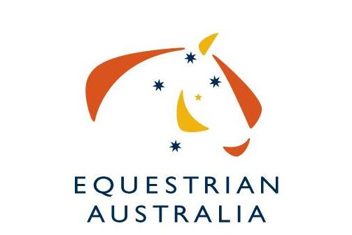
National High Performance Program
National Carriage Driving Squad 2017
Expression of Interest

Driver’s Name:
EA Membership No:

Address:
 |  |  | Postcode:
Telephone: | Day |  | Mobile:
E-mail:

Squad you are nominating for:
Horse Four in Hand
List horses:
Horse Pairs

List horses: | 1.  2.
Horse Singles
List horse:

Pony Four in Hand
List horses:
Pony Pairs
List horses: | 1.  2.
Pony Singles
List horse:

Competitive History
Competition: |  | Date:
Class: |  | Score:
 |  | Placing:
Competition: |  | Date:
Class: |  | Score:
 |  | Placing:
Competition: |  | Date:
Class: |  | Score:
 |  | Placing:
Competition: |  | Date:
Class: |  | Score:
 |  | Placing:

Any other relevant information:

Please attach any other information that may assist your application
I hereby make my application to be considered for the 2017 National Carriage Driving High Performance Squads and if selected, agree to abide by the rules and regulations of EA.

SIGNED: .................................................................................. DATE: ....../....../......

Due Date: Friday 6th January 2017
This form is to be completed and returned to:
Equestrian Australia
Stefanie Maraun: PO Box 673, Sydney Markets NSW 2129
Fax: 02 9763 2466
Email: stefanie.maraun@equestrian.org.au

