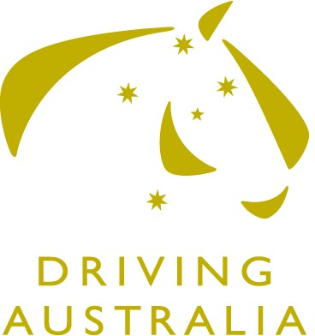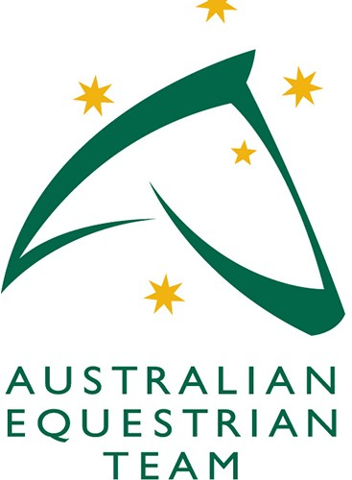
APPLICATION FOR CHEF D’EQUIPE

FEI World Driving Championships for Pair of Horses

Le Pin-au-Haras (FRA)

27 September- 1 October 2023
PER SO N A L DETA I L S :
Name: |  | FEI Member No:  And/or EA Member No:
Street Address:
Suburb: | State: |  | Postcode:
Country:
Phone: | Email:
SIGNED: DATE:
I hereby make my application to be considered for Chef d’Equipe for the FEI World Driving Championships Pair of Horses and if selected, agree to abide by the rules and regulations of the competition, FEI and Equestrian Australia

CON S E N T OF APPL I C A N T :
CHEF D’EQUIPE APPLICATION:
Please include previous history, involvement in the discipline etc.

Please note
- The role of Driving Pair of Horses Chef d-Equipe has no financial assistance from EA.
- Direct family members of AUS Team Drivers are requested not to apply

Please email this form and any additional information that may assist your application to Di Saunders, Equestrian High Performance Sports Manager, di.saunders@equestrian.org.au by Friday 18 August 2023. Thank you for your interest in Australian Driving!

