

**2016**

**Equestrian Sport New Zealand**

**Endurance National & FEI Judges, Technical Delegate & Veterinary**

**Training Courses**

**6th, 7th & 8th May 2016**

**Copthorne Hotel & Conference Centre**

**110 Fitzherbert Avenue**

**Palmerston North**

**New Zealand**

***Information Sheet & Registration Form***

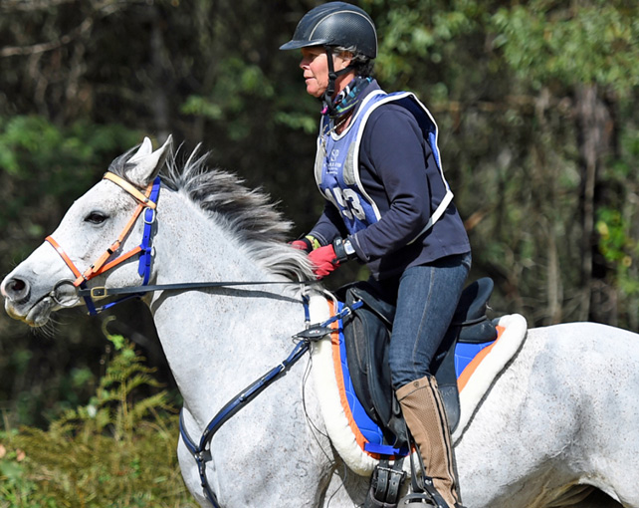

**Location:**

Copthorne Hotel & Conference Centre

110 Fitzherbert Avenue

Palmerston North

New Zealand

Phone: (0064) 06 356 8059

Email: [dale.shannon@millenniumhotels.com](mailto:dale.shannon@millenniumhotels.com)

Contact for accommodation: Kathryn at above number and mention New Zealand Endurance.

**Programme:**

Friday 6th May 2016

8am – 6pm Judge Level II Course

8am – 6pm Endurance Veterinary Course (EOV)

7pm – Late Dinner (with guest speaker TBC)

Saturday 7th May 2016

8am – 6pm Judge & TD Level I Course

8am – 12pm Endurance Veterinary Course (EOV)

12pm – 6pm Endurance Treatment Veterinary Course (EVT)

7pm – Late Course Dinner

Sunday 8th May 2016

8am – 4pm TD Level II Course

8am – 4pm Endurance Treatment Veterinary Course EVT)

**Candidates:**

Bookings are open. We have Australian attendees for both the Veterinary and the Officials courses.

Judge Level II Course is for those Officials with ratings seeking promotion or maintenance of their status.

Judge & TD Level I is for those candidates wishing to start a career as an FEI or National Official. This course is ideal for Board Members, OC members, club members and riders wishing to expand their knowledge of Endurance activity.

TD Level II Course is for TDs with ratings seeking promotion or maintenance of their status. It is also useful those staying over from Saturday and heading home later in the day.

**Costs:**

Sponsorship has been received from FEI and Toft Endurance so costs have been minimised. A huge thank you to them both for their support.

Judge & TD Level I Course only : $25

Judge & TD Level II Course: $50 (Saturday Level I Course Free)

FEI Veterinary Courses: $60 for one (1)

$100 for two (2)

**\*\*Stop Press\*\***

**Toft Endurance is sponsoring the course dinner on the Saturday.  All you contribute is your presence and own bar tab.  Given there will be a large Australian contingent this dinner is now an ideal networking opportunity for Trans-Tasman Officials.**

**Ron suggests:**

**Those seeking Promotion or Maintenance attend all three days and course dinner for one fee of $50.**

**Those seeking to start an Official career as FEI Candidates or National Judges and/or TDs do the Saturday plus the dinner and whatever time they can spare Sunday for one fee of $25.**

**More details will be circulated as they come to hand.**

**\*\*Please Note:**

**You are responsible for arranging your own accommodation whether it is at the Copthorne Hotel or elsewhere. We have negotiated a special price at the Copthorne Hotel which is $80 per standard room & $120 per Superior room per night. Please refer to New Zealand Endurance when booking.**

**Friday night dinner & breakfast Saturday & Sunday mornings is at your expense. (Breakfast $19 at Copthorne Hotel). Lunch & morning & afternoon teas included in course fees.**

**Please fill in the following registration form & return to:**

**Wendy Farnell**

**211 Lismore Mayfield Rd**

**RD 5**

**Ashburton 7775**

**Or email to:** [**jondy.tnc@xtra.co.nz**](mailto:jondy.tnc@xtra.co.nz)

***Registration Form:***

**Name:**

**Address:**

**Phone: Email:**

**I would like to attend the following course (please tick)**

Judge & TD Level I Course only. Fee Paid $25 Yes / No

Judge & TD Level II Course. Fee Paid $50 Yes / No

FEI Veterinary Course only. Fee Paid $60 Yes / No

FEI Treatment Veterinary Course. Fee Paid S60 Yes / No

Both FEI Veterinary Courses. Fee Paid $100 Yes / No

Friday - Dinner - own expense

Saturday Breakfast Cost Paid $19 Yes / No

Saturday Night Official Dinner – Free Kindly Sponsored by Toft Endurance

Sunday Breakfast Cost Paid $19 Yes / N0

**If you are requiring further information please contact any of the following:**

Wendy Farnell: [jondy.tnc@xtra.co.nz](mailto:jondy.tnc@xtra.co.nz) 0274 934851 03 3036144

Ron Guest: [ron.beth@farmside.co.nz](mailto:ron.beth@farmside.co.nz) 021 783 101 07 872 7785

Kelly Haywood: [masonk1@live.com](mailto:masonk1@live.com) 021 168 7933