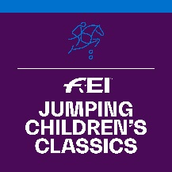

FEI Jumping Children’s Classics 2018

PARTICIPATION FORM

The NF of informs the FEI that it will organise the following FEI Jumping Children’s Classics Competition(s):

Tour | DATES | EVENT SITE
GOLD
SILVER
BRONZE

Please note that Gold Tour events must take place before 8 October 2018.

Name of FEI Judge:
(Minimum level 2 Judge from home or abroad)
FEI ID:
Email address of FEI Judge:

Please give name and contact details of the person to be contacted at your NF in relation to this Competition.

Name:
Position:
Email address:
Phone number:

In my capacity as President of the National Federation, I declare to do my best to ensure that the rules for this Competition are implemented and that the deadlines for returning the results are respected.

Date : NF’s stamp :

Signature : _____________________________

Completed forms to be returned by 30 June 2018 to:

Marijn Dubbeldam, FEI Jumping Department
Email : marijn.dubbeldam@fei.org
Or by Fax: + 41 21 310 47 60

