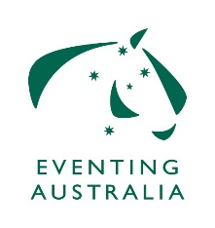 | EXEMPTION APPLICATION:  EA 520.3 EA MINIMUM ELIGIBILITY REQUIREMENTS (Applies to FEI Events)
Rider’s Name:
EA Membership No.
FEI Membership No.
Address:
 |  |  | Postcode:
Mobile No:
E-mail address:
Horse Name:
Horses EA No: |  | Horses FEI No:
Reason for exemption requested incl. level of competition:
Please ensure that you attach detailed summary of both the horse and the rider’s performance record, including all the horse’s competitions at national and international events during the current and previous years.

EA 520.3 EA MINIMUM ELIGIBILITY REQUIREMENTS (Applies to FEI Events)
To be completed when a horse and/or rider combination meets FEI MER Requirements but does not meet National MER Requirements. Exemption applications should be sent to your State Eventing Committee for review and approval. The application will then be forwarded to Caiwen Cusworth caiwen.cusworth@equestrian.org.au for decision by the EA Eventing Committee .

