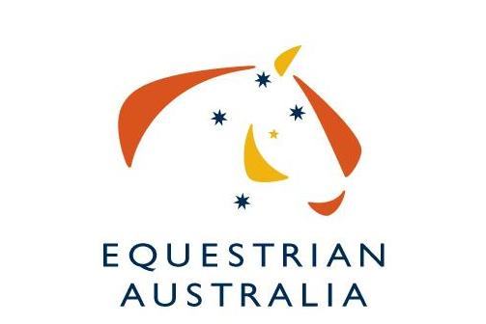
Equestrian Australia Ltd.
ABN 19 077 455 755

www.equestrian.org.au
PO Box 673, SYDNEY MARKETS, NSW, 2129 – Fax 02 9763 2466

Nomination for Election to
the Australian World Jumping Cup Committee
for the position of the World Cup Committee EA Representative.

I, |  |  | of
 | (Full Name) |  |  |  |  | (Address)
 | (Address)
 | (Telephone) |  |  |  |  |  |  | (E-mail Address)
 | (EA Member No.)

wish to nominate for election to the Australian World Cup Committee

Signed

Date

Declaration
I have read the FEI Internal Regulations, EA Committee By-Laws and the Position Description for the Australian World Cup Jumping Committee and understand the commitment in time and contribution I will be expected to make. I also confirm that I meet the other requirements to be a Committee Member of the EA, especially in terms of skills and the need to work for the good of the whole Federation and the whole of the sport.

Signed

Date:

Please send this form and completed resume to the EA National Office.

Attn: Sara Latham

P.O Box 673 Sydney Markets NSW 2129 or

Fax: 02 9763 2466

Email sara.latham@equestrian.org.au

Closing date: Monday 19th October 2015

Résumé Template (for hand-writing or typing)
for use by Nominees for the
Elections to the Australian World Cup Jumping Committee

Nominees for election to the Australian World Cup Jumping Committee must use this template to give information on their background and their commitment to serve on the Committee.

Full Name |  |  |  | EA Membership No
Address | Street No. & Name
Address | Suburb/City |  |  |  | Postcode
 |  |  |  |  |  | State
Tel. No. |  | Fax No.
Mobile |  | E-mail

Training & Education

“Sport Governance” Skills and Experience | (Membership of committees, sub-committees, etc.)

Sport Knowledge and Involvement | (Achievements and standard as participant: rider, official, event manager/operative, volunteer at events or in projects, etc.)
Business and Related Skills and Experience
Other Relevant Information
How much time are you willing to dedicate to Committee duties? (E.g. Review of documentation for the Committee and the work that flows from it; assistance to National Office staff if requested; participation in projects; etc.) |  | (Average hours per week)

Date | Signature

Please send this form and completed resume to the EA National Office.

Attn: Sara Latham

P.O Box 673 Sydney Markets NSW 2129 or

Fax: 02 9763 2466

Email sara.latham@equestrian.org.au

Closing date: Monday 19th October 2015

